BUDT703_0501_06

Project Proposal

Nisarg Patel, Kai-Hsiang Lin, Parth Nanwani, and Snigdha Madiraju

**Determine a Meaningful Brand Name for Your Project**

* CP HotSpots

**Mission Statements**

1. To offer insights to potential new business owners and help them understand target customers and determine pricing strategy to maximize growth potential and profit margin.
2. To provide useful information about restaurants around College Park and to help newcomers explore local restaurants and find a good place to dine at.

**Mission Objectives**

1. To identify which city do the most reviewers come from so restaurants can recognize their target customers.
2. To identify the most popular PriceLevel so that restaurants can make better pricing decisions that attract more customers.
3. To find the best rating restaurant across all PriceLevel so that consumers have a wide variety of choices of high quality restaurants.
4. To find the top 3 best rating restaurants, so newcomers can find the best places to dine at.
5. To find the restaurant that operates for the longest time so newcomers know the restaurant with the highest possibility to be opened.

**Describe Business Processes / Transactions in Sentences**

1. Which city has the most number of customers that posted a review?
2. What PriceLevel is the most popular among all restaurants?
3. Which restaurant, across all PriceLevel, has the highest rating?
4. Which are the names of the top 3 restaurants without considering their PriceLevel?
5. Which restaurant has the highest opening hours?

**Design and ER Schema**

* Entities, Attributes and Primary Keys
  + Restaurant (rstId, rstName, rstLocation, -rstStreet, -rstCity, -rstState, -rstZip, rstPhone, rstStar, rstPriceLevel, rstReviewCount, rstCategory [1..5])
  + Customer (cusId, cusName, -cusFName, -cusLName, cusOrigin, -cusCity, -cusState)
  + Source (srcId, srcName)
  + OperationTime (oprDay, oprHours, -oprStart, -oprEnd, =totalHours)
* Relationships, Attributes, Degrees, Participating Entities and Constraints
  + Review (rvwId, rvwStar, rvwDate, rvwPhotoCount): ternary relationship
    - 1 Customer and 1 Restaurant to 1 Source
    - 1 Customer and 1 Source to 0 or many Restaurants
    - 1 Restaurant and 1 Source to 0 or many Customers
  + Open: binary relationship
    - 1 Restaurant to 1 or many OperationTime
    - 1 OperationTime to 1 Restaurant

**Design an ER diagram on Lucidchart**

* See Lucidchart here: <https://lucid.app/documents/view/36454fbb-14c1-4ce0-96f3-98416fa3f8c7>

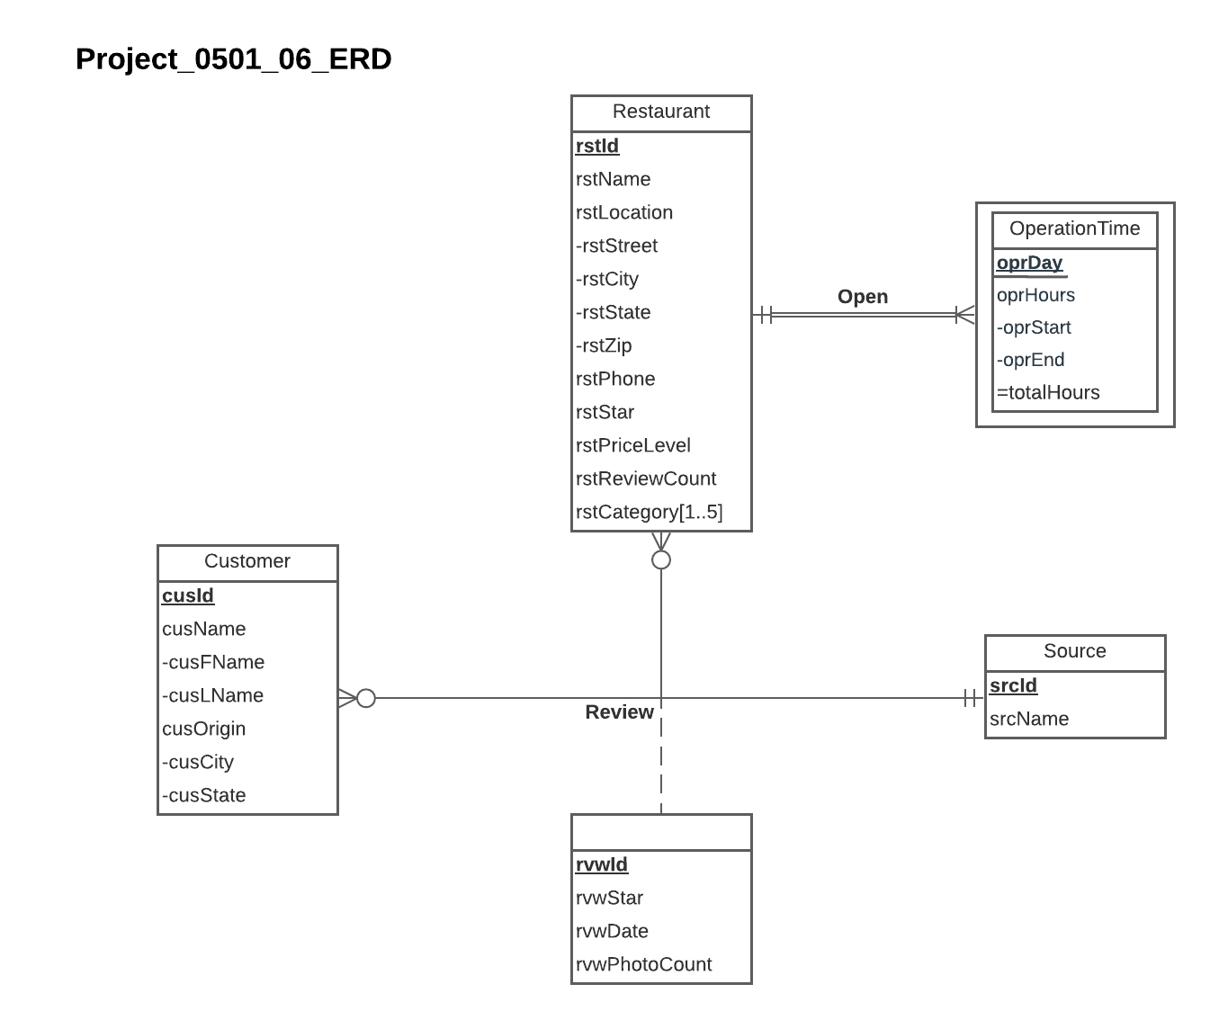

**Relations**

Restaurant (rstId, rstName, rstStreet, rstCity, rstState, rstZip, rstPhone, rstStar, rstPriceLevel, rstReviewCount)

Customer (cusId, cusFName, cusLName, cusCity, cusState)

Source (srcId, srcName)

RestaurantCategory (*rstId,* rstCat)

OperationTime (*rstId*, oprDay, oprStart, oprEnd)

Review (rvwId, *rstId, cusId, scrId,* rvwStar, rvwDate, rvwPhotoCount)

**Functional Dependencies**

rstId → rstName, rstStreet, rstCity, rstState, rstZip, rstPhone, rstStar, rstPriceLevel, rstReviewCount

cusId → cusFName, cusLName, cusCity, cusState

srcId → srcName

rstId, rstCat →

rstId, oprDay → oprStart, oprEnd

rvwId → rstId, cusId, scrId, rvwStar, rvwDate, rvwPhotoCount

**Business Rules**

[R1] When a restaurant is deleted from the database, the corresponding restaurant category information should be deleted from the database.

[R2] When a restaurant changes information in the database, the corresponding restaurant category information should be changed accordingly.

[R3] When a restaurant is deleted from the database, the operation time information of that restaurant shall be removed from the database.

[R4] When the information on a restaurant is changed in the database, the corresponding operation time information should be changed accordingly.

[R5] When a restaurant is removed from the database, all reviews posted for that restaurant should be removed.

[R6] When information about a restaurant is updated or changed in the database, the corresponding review information for that restaurant should be changed accordingly.

[R7] When a customer is removed from the database, all reviews posted by the customer should be removed.

[R8] When a customer updates his or her information, the corresponding review information posted by that customer should be changed accordingly.

[R9] When a source is removed from the database, all reviews posted on that source should be removed.

[R10] When information about a source is updated or changed in the database, the corresponding review information posted on that source should be updated accordingly.

**Referential Integrity**

| Relation | Foreign Key | Base Relation | Primary Key | Business Rule | Constraint: ON DELETE | Business Rule | Constraint: ON UPDATE |
| --- | --- | --- | --- | --- | --- | --- | --- |
| RestaurantCategory | rstId | Restaurant | rstId | R1 | CASCADE | R2 | CASCADE |
| OperationTime | rstId | Restaurant | rstId | R3 | CASCADE | R4 | CASCADE |
| Review | rstId | Restaurant | rstId | R5 | CASCADE | R6 | CASCADE |
| Review | cusId | Customer | cusId | R7 | CASCADE | R8 | CASCADE |
| Review | srcId | Source | srcId | R9 | CASCADE | R10 | CASCADE |

**Sample Data**

Restaurant ('R08', 'Ledo Pizza', '4509 Knox Rd', 'College Park', 'MD', '20740', '3014228122', 4.2, '$$', 804)

Customer ('C13', 'Ronnie', 'T', 'Hyattsville', 'MD')

Source (‘S01’, ‘Yelp’)

RestaurantCategory (‘R08’, ‘Pizza’)

OperationTime (‘R08’, ‘Mon’, 1100, 2200)

Review ('V40', 'R08', 'C40', 'S02', 3.0, '2019-11-15', 3)